Name:ch.karthik

Reg.no:23BCE20022

**Week 7:**

1. Write a Python Program to Find the Largest Number in a List

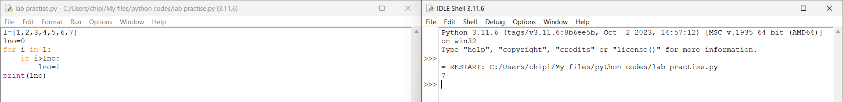

1. Write a Python Program to Find the Second Largest Number in a List

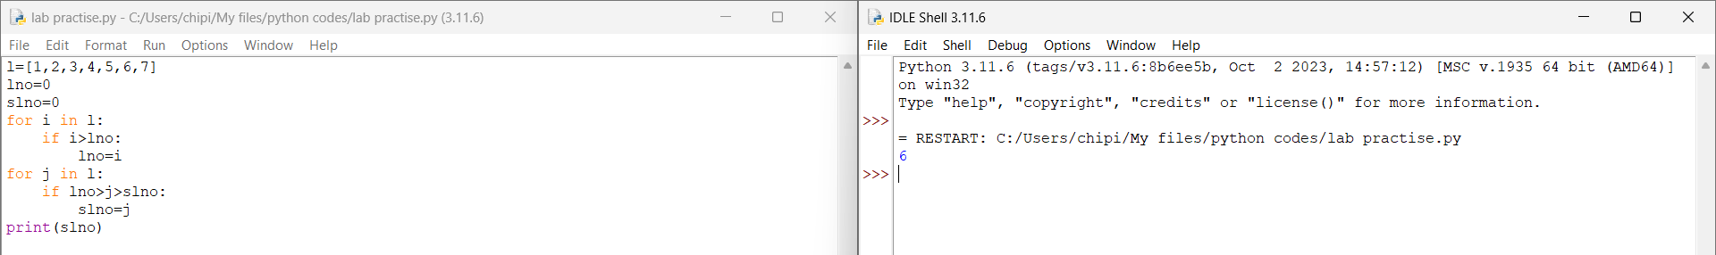

1. Write a Python Program to Put Even and Odd elements in a List into Two Different Lists

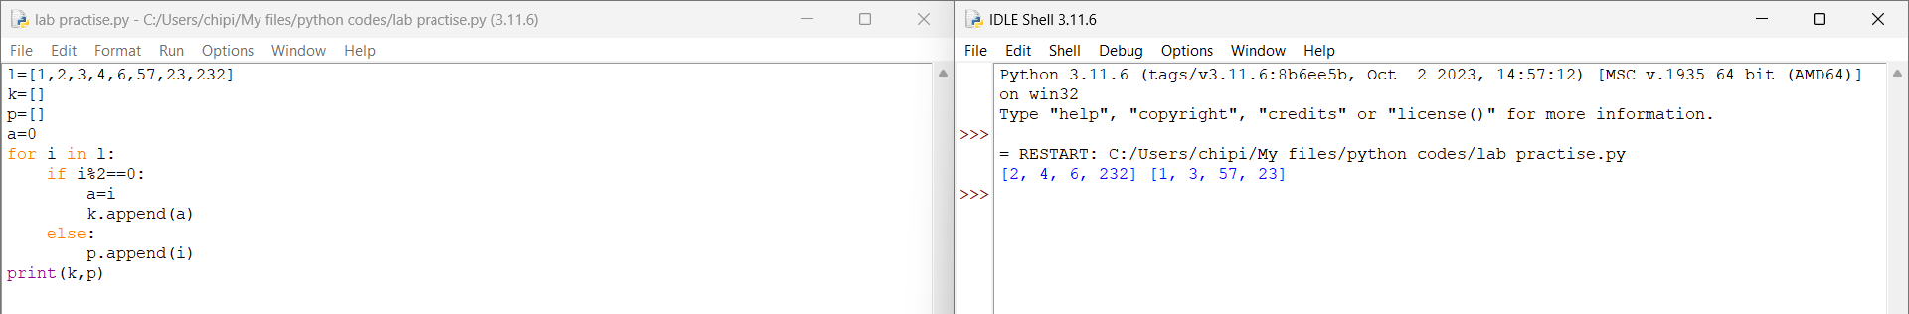

1. Write a Python Program to Merge Two Lists and Sort it

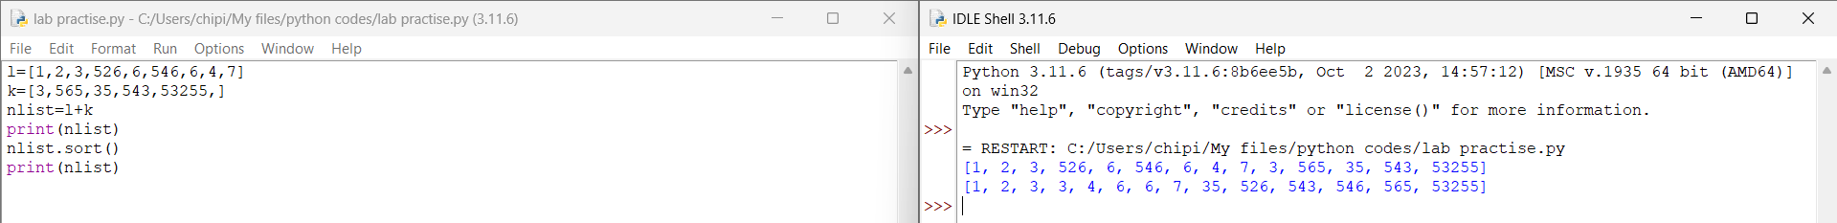

1. Write a Python Program to Sort the List According to the Second Element in Sublist

